MetaDiv Builder Platform

User Manual
Version 1.7.3
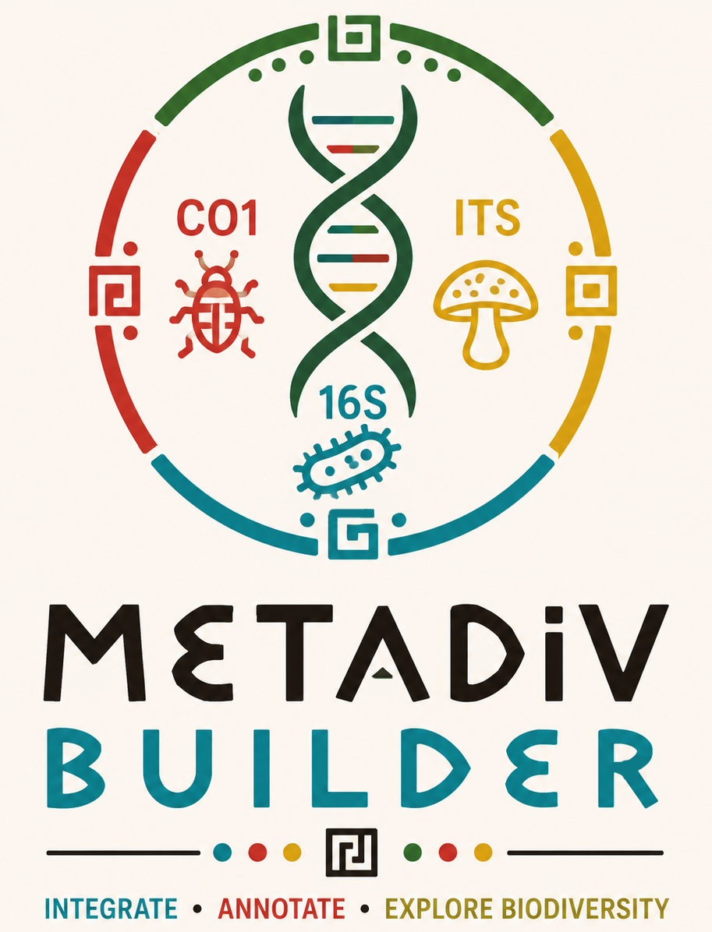

Table of Contents
- Introduction
- Platform Overview
- Software Architecture
- Directory Structure
- Input Data
- Reference Databases
- Running MetaDiv Builder
- Output Structure
- Integration with R
- BLAST Module
- Subset Extraction Tools
- Future Developments
- Citation

1. Introduction
MetaDiv Builder is an open-source platform developed to standardize the integration, taxonomic annotation, ecological annotation, and downstream preparation of metabarcoding datasets. The platform was designed to bridge the gap between bioinformatic sequence processing and ecological data analysis by providing a unified framework capable of transforming heterogeneous metabarcoding outputs into standardized databases suitable for biodiversity studies.
Current metabarcoding workflows frequently generate operational units such as OTUs, ASVs, zOTUs or MOTUs using different sequencing technologies and bioinformatic pipelines. Although these approaches produce reliable taxonomic information, the resulting datasets often require extensive post-processing before they can be analyzed using ecological methods. MetaDiv Builder was developed to automate this transition while preserving taxonomic traceability and facilitating reproducible analyses.
The current version supports three molecular markers, ITS, 16S rRNA and CO1, and has been designed as a modular platform that can incorporate additional markers and ecological databases in future releases.

2. Platform Overview
MetaDiv Builder is organized as an integrated platform composed of several independent modules that work sequentially during the processing of metabarcoding datasets. The complete workflow begins with the import of abundance tables, representative sequences and SINTAX taxonomic assignments. The software then performs taxonomic harmonization, assigns persistent identifiers, incorporates ecological annotations and finally exports standardized datasets ready for downstream ecological analyses.
This modular organization allows each component of the platform to evolve independently while maintaining compatibility with previous releases. As a result, new taxonomic databases, ecological classification systems and analytical modules can be incorporated without modifying the core architecture of the software.
(Figure 1. General workflow of MetaDiv Builder.)

3. Software Architecture
MetaDiv Builder is organized into five functional modules that together form a complete workflow for metabarcoding data integration.
The first module performs taxonomic integration by reading the original abundance tables, representative sequences and SINTAX taxonomic classifications. During this stage, taxonomic names are parsed according to user-defined confidence thresholds and collapsed into standardized taxonomic units. Representative sequences are selected automatically and each resulting taxon receives a persistent identifier (SPPN), which guarantees complete traceability throughout the analytical workflow.
The second module performs ecological annotation by incorporating information from specialized ecological reference databases such as FungalTraits and FAPROTAX. Because this module is independent from taxonomic integration, additional ecological databases can be incorporated in future versions without modifying the taxonomic engine.
The third module generates standardized output files designed for ecological analyses. These include abundance tables, taxonomy tables, representative sequences and sample metadata formatted for direct import into R.
Additional modules provide local BLAST utilities for sequence comparisons and a collection of tools for extracting subsets of the integrated databases according to taxonomic groups, sample lists or user-defined queries.
(Figure 2. Software architecture.)

4. Directory Structure
MetaDiv Builder follows a modular directory organization in which each folder performs a specific role within the platform. This structure separates user input, reference databases, software modules and analytical outputs, facilitating reproducible workflows and simplifying future updates.
The docs directory contains the official software documentation, including the user manual, the platform architecture and graphical resources such as the MetaDiv Builder logo.
The input directory stores all metabarcoding datasets provided by the user. Separate folders are maintained for ITS, 16S and CO1 datasets, each containing an abundance table, a FASTA file with representative sequences and the corresponding SINTAX taxonomy file.
The databases directory contains all reference databases required by the platform. These are divided into taxonomic reference databases used during taxonomic assignment and ecological reference databases used during functional annotation.
The output directory stores all results generated by MetaDiv Builder. Independent output folders are created for each molecular marker and include the integrated taxonomic database, ecological annotations, standardized R files, Krona visualizations and intermediate concatenated tables.
The R directory contains the official analysis scripts distributed with the platform. These scripts provide reproducible workflows for exploratory analyses, alpha diversity, Hill numbers and community ordinations.
The BLAST directory contains utilities for local sequence comparison, while the subsets directory provides tools for extracting subsets of the integrated database according to different user-defined criteria.
META DIV BUILDER V1.7.3/

